T1 AéroWing Gate Specification
Manufacturer - Matrix Research Limited
Product Brand - ACX

Design, Throughput, Dependability
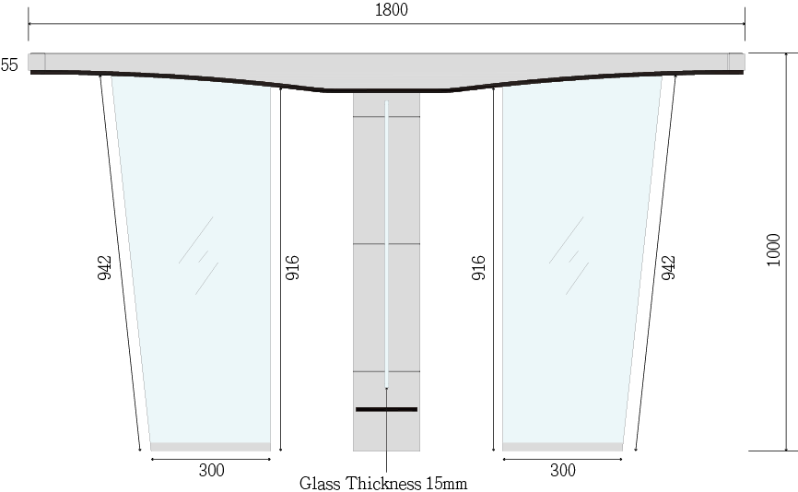
Design
- This AéroWing Gate (the Gate) is in T-shaped, with the two glasses on the sides in trapezoid
- The Gate’s material (SUS#316 or others), appearance (colour spray or electroplating) length, surface (wiredrawing/glossy/matte), obstacle (length, height, printed pattern), card area, installation (flooring panels) are customizable
- Standard unit size: 1800mm (L) x 180mm (W) x 1000mm (H). The overall thickness of the turnstile’s top cover is 55mm, with the max. thickness of 100mm in the center of the top cover
- Standard dimensions: 720mm door wing height, 600mm / 900mm passage width (two obstacle wings made of 8mm tempered glass)

Throughput
- The Gate is set with 9 kinds of dual-direction control modes (alternative), while providing real-time status monitoring with its 8 pairs of OMRON sensors (standard)
- Capacity (per minute per direction): more than 25 people in the normally closed position (open position as an alternative)
- Operating speed time is 0.8-1.6s (customizable)
- Door opening: 90° to the middle; movement angle: 166°

Dependability
- Lifespan: 15M times; Mean Cycles Between Failures (MCBF): 10M times

Safety
- The Gate is equipped with a 2D Laser Module (99% detection accuracy, higher compared with IR). This Laser Module is a ground-level safety sensor ensuring child-friendly passage
- Laser safety class: Class 1 (IEC 60825-1:2014), which means it is safe for human eyes
- The Low Noise Operation guarantees an average sound level of under 60db, which will not cause hearing damage
- The Gate has a standard external electrical interface, with photoelectric safety isolation.
- Advanced protection to prevent electrical leakage, pinching, and collision is also put in the Gate
- Lock disengages in case of a power outage (fail-safe operation)

Technology (Access Control)
- The Gate can be integrated with the Lift Destination Control System and Building Visitor Management System
- The Gate supports a temperature check and a multi-technology reader. The reader can be set by users to handle different access conditions, including human biometric technologies (Facial Recognition and Palm Vein Recognition), Mobile Scramble/Fixed QR Code, Contactless Smart Card 13.56MHz, Octopus, Bluetooth, and NFC.
- All the access devices shall be installed under the glass top cover of the turnstile, excluding the temperature sensor detector
- If the body temperature device is to be installed on top of the turnstile’s top cover, the max. dimensions cannot exceed 120mm (L) x 80mm (W) x 75mm (H)
- If the facial camera is to be installed on top of the turnstile’s top cover, the max. dimensions cannot exceed 110mm (L) x 70mm (W) x 40mm (H)
- The facial recognition algorithm shall be Face++
- The Palm Vein recognition technology shall be Fujitsu PalmSecure-F Pro technology
- The Gate’s scanning ranges from 60cm to 180cm. It also caters to wheelchair users and people with luggage or trolley.
- The devices are installed on the Gate top surface area, with LED lights to indicate access status and passage direction.
- It has an enhanced anti-tailgating (also known as anti-passback) design, preventing multiple people passing the Gate at the same time
- The Gate is installed with a 5.5” LCD to display the system message, the access granted and access denied message, and the destinated lift number (if the Gate is integrated with the Lift Destination Control System)

Electrical & Environmental
- Power supply: AC220V ±10% 50Hz; AC110V ±10% 60Hz (Optional)
- Frequency: single phase 50Hz to 60Hz
- Operating voltage: DC24V
- Current: static 300mA; dynamic 3A (maximum operating current)
- Operating temperature: 0°C / 32°F to 60°C / 140°F
- Storage temperature: -20°C / -4°F to 60°C / 140°F
- Relative humidity: 5% to 95% (non-condensing)

